KLUV Coin

[Home](https://www.kluvcoin.io/index.html) [About](https://www.kluvcoin.io/about.html) [Goodwill](https://www.kluvcoin.io/goodwill.html) [Contact Us](https://www.kluvcoin.io/contact-us.html)

**About**

BUY NOW on [https://pancakeswap.finance/swap](https://pancakeswap.finance/swap/)   
See Smart Contract at <https://bscscan.com/address/0x3A68A9Cd188C324a45c06866eFD1C79605B66827>   
Token Name: Kismet Love  
Symbol: KLUV  
Decimals: 8

Kismet International Limited Coin Development has established a Public/Private Partnership with the Kringle Society to support their Goodwill efforts in the world. Within this partnership arrangement members of the Kringle Society will pay all of their Program Fees using the KLUV Token starting in the first quarter of 2022. As the KLUV Token grows in popularity within the market and as funding increases, Kismet International Limited will supply funds to support Goodwill Projects of the Kringle Society. The Kringle Society has long ago set their objective of gathering a Billion people to be a part of their Private Society with the mission to end poverty globally. 1,000,000,000 KLUV Tokens have been locked on day one as a reward to those builders within the Kringle Society for achieving this objective of gathering a billion people together which will bring mutual benefits within this Public/Private Partnership.   
  
Kismet means DESTINY. May the destiny we form within this Public/Private Partnership lead to world peace and happiness for all.

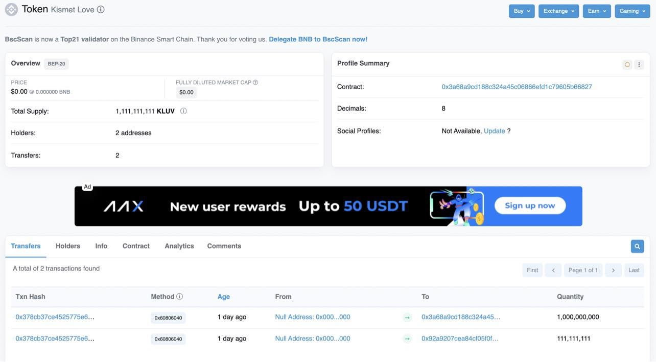

© 2022 KLUV COIN. All Rights Reserved.

KLUV Coin

[Home](https://www.kluvcoin.io/index.html) [About](https://www.kluvcoin.io/about.html) [Goodwill](https://www.kluvcoin.io/goodwill.html) [Contact Us](https://www.kluvcoin.io/contact-us.html)

The KLUV Coin is a way to raise additional funds to support the Kringle Society Goodwill to feed the poor and needy.



The pictures below are people that received a couple weeks worth of food from the TBC Kringle Society Goodwill at various times and locations. Their situations are beyond our imaginations. As you can see from these images, some suffers from chronic health conditions, like persons with paraplegia, also people with cognitive disabilities, and people with intellectual disabilities such as people with down syndrome. They strongly believe that no particular group of humans should lack the minimum, which is food, not to mention that of medical attention. Some of the mothers after receiving the food, shed tears of joy, and some even prayed like they speak a language they did not really understand. They would say they prayed in tongues to thank the team providing the Goodwill.   
  
**The KLUV Coin will raise additional funds to support the Kringle Society Goodwill projects all over the world.**

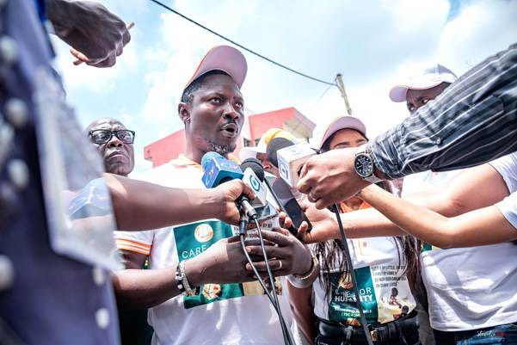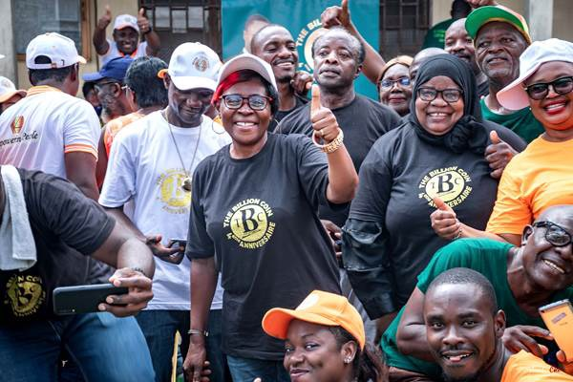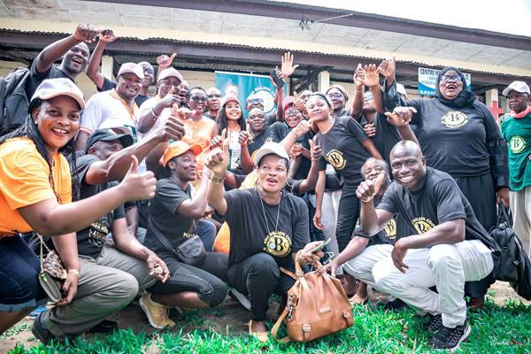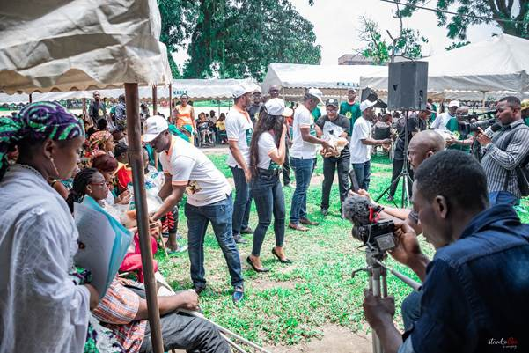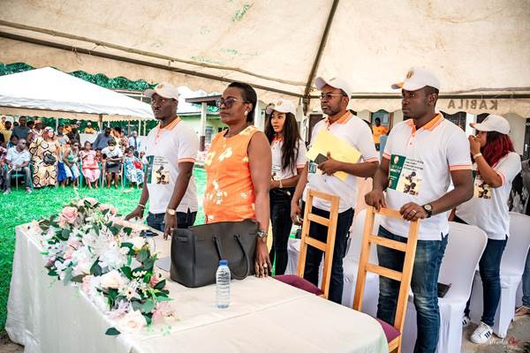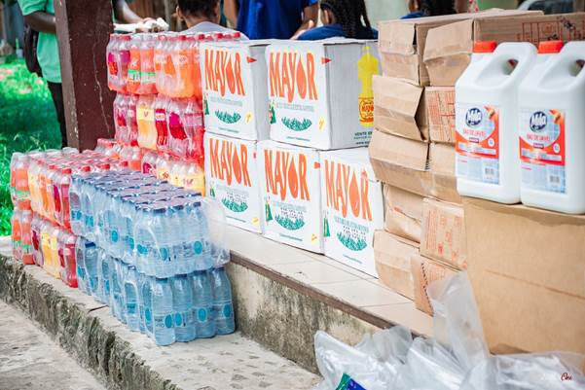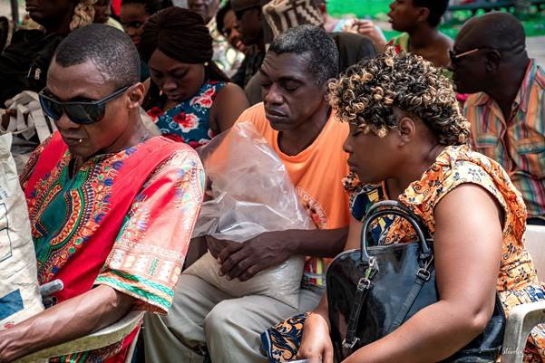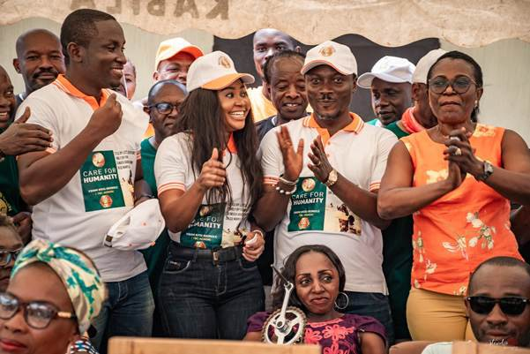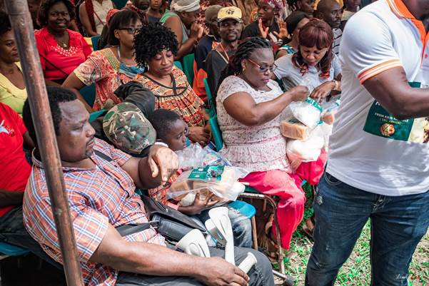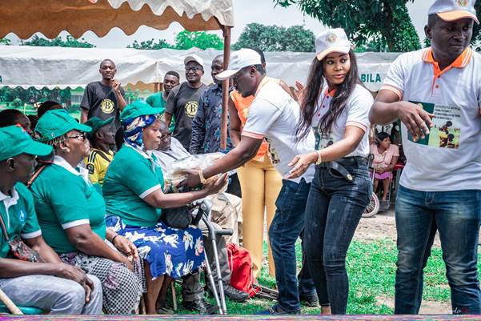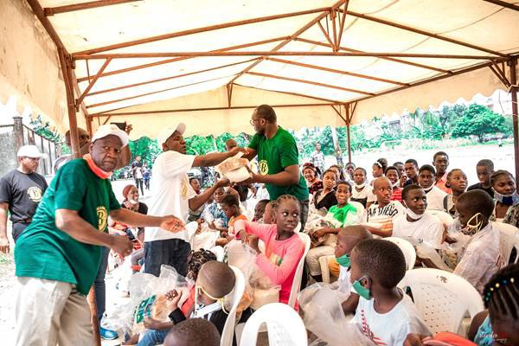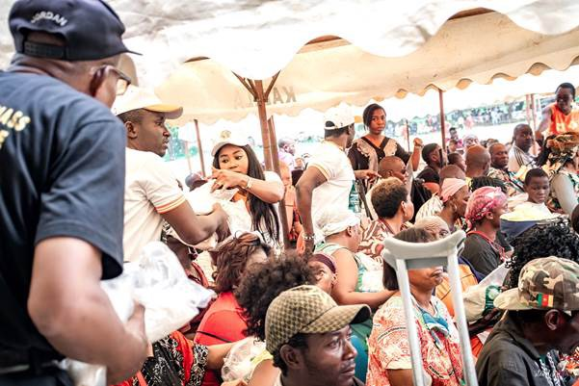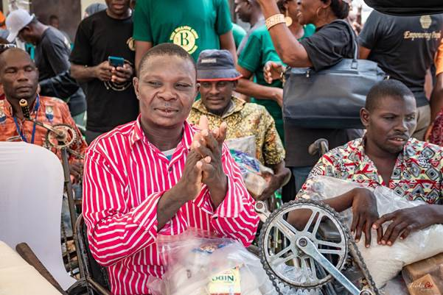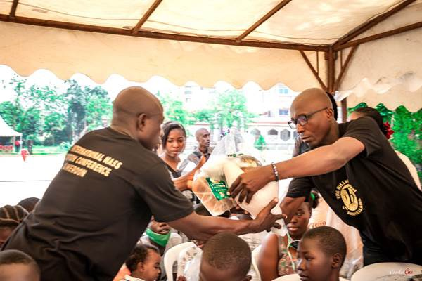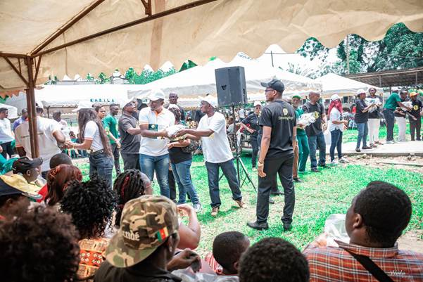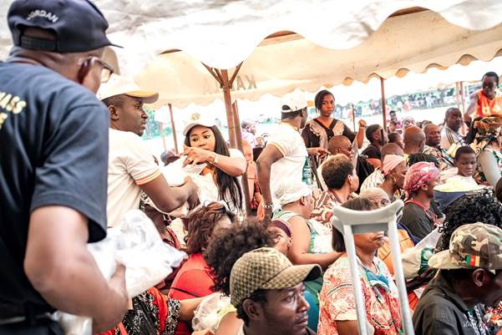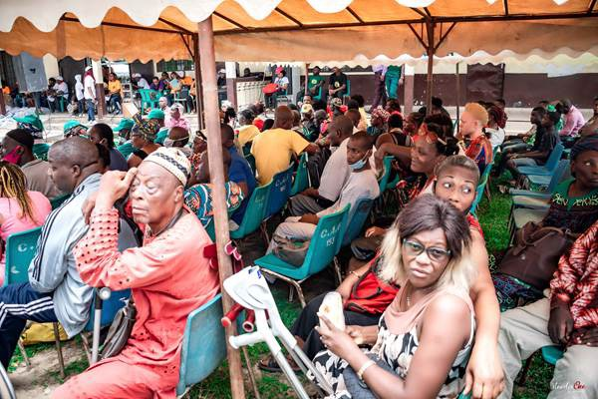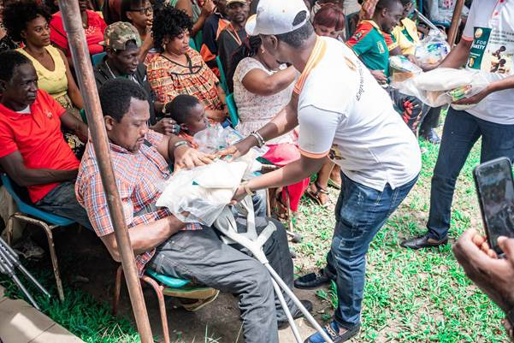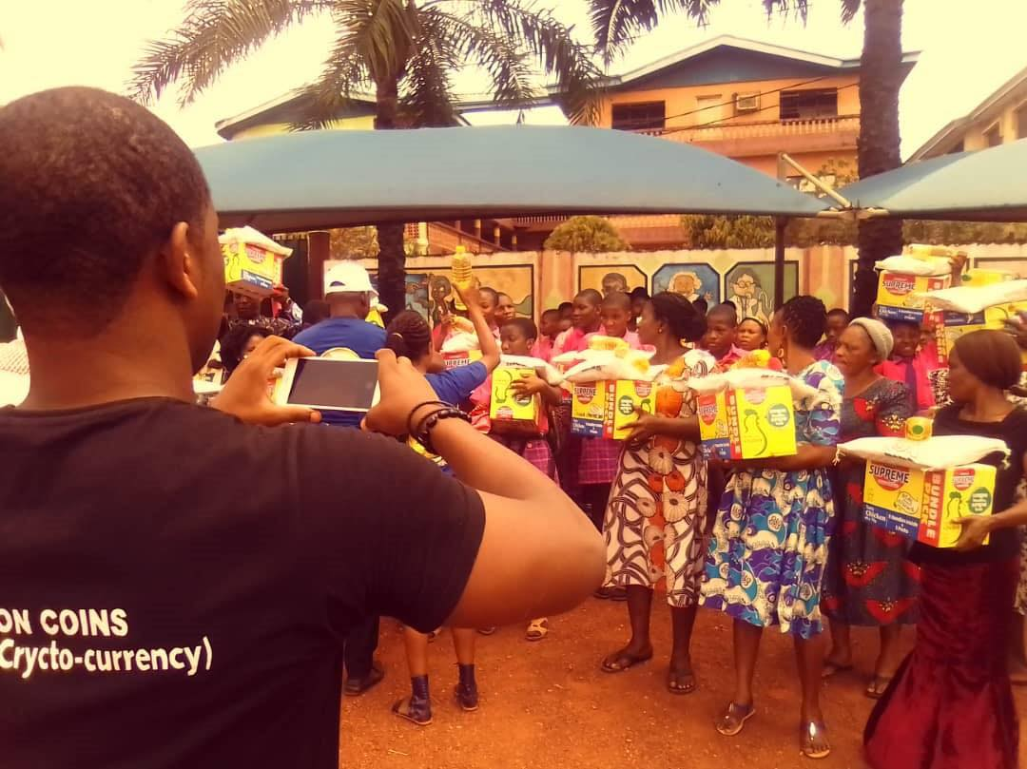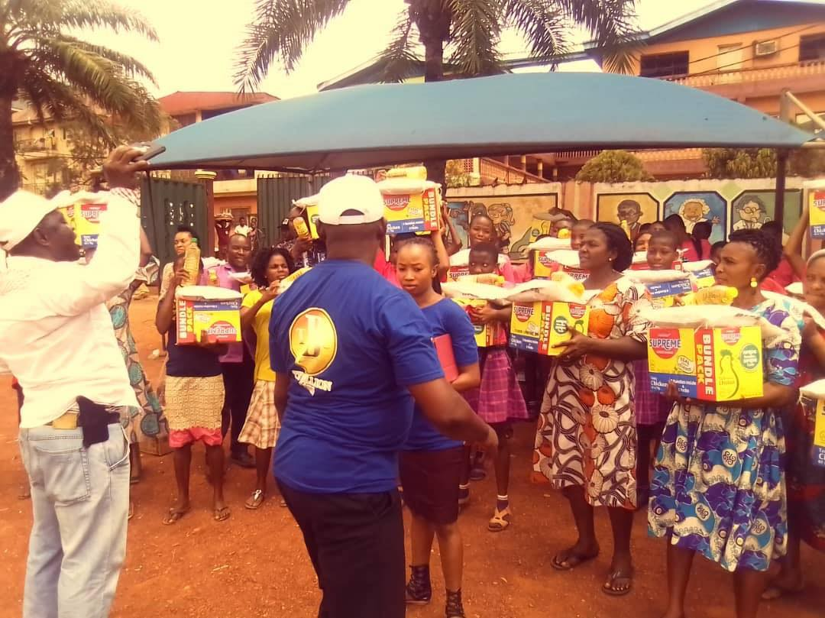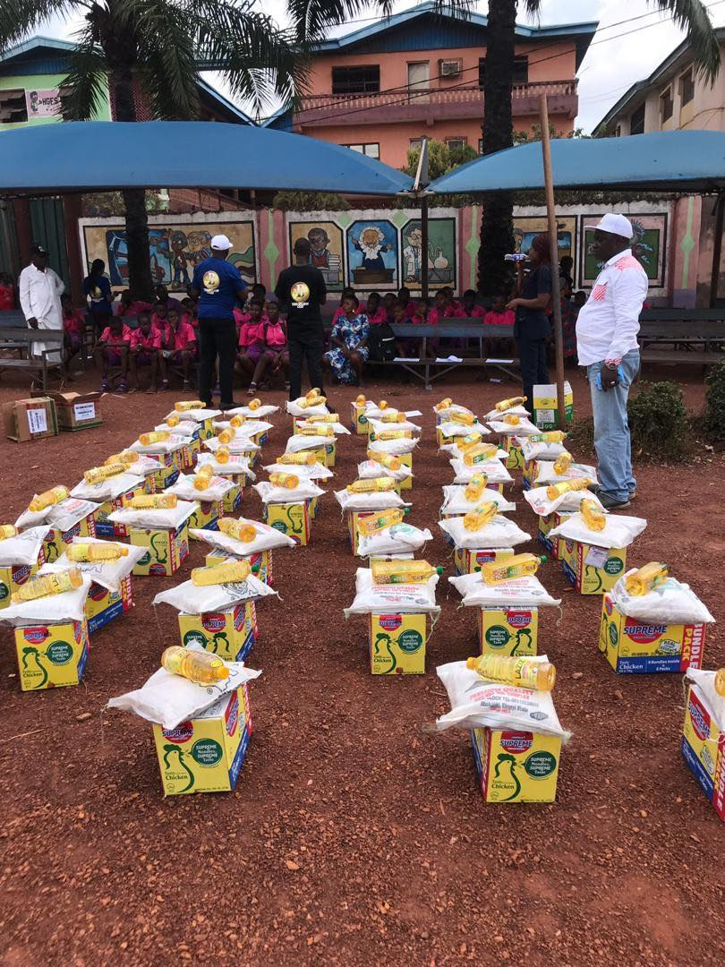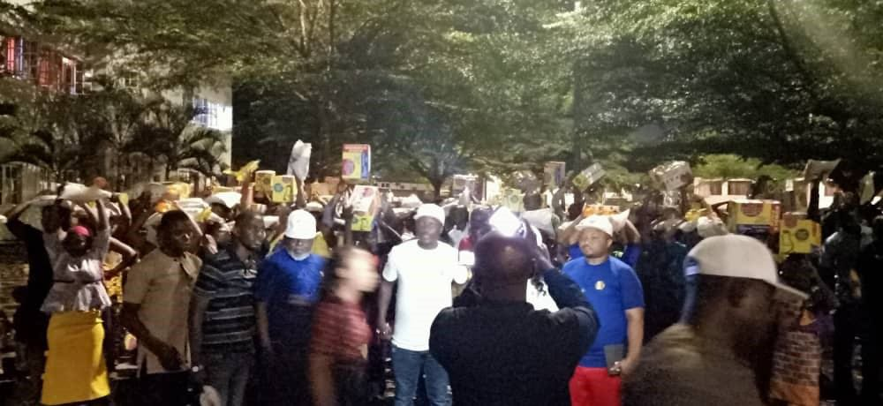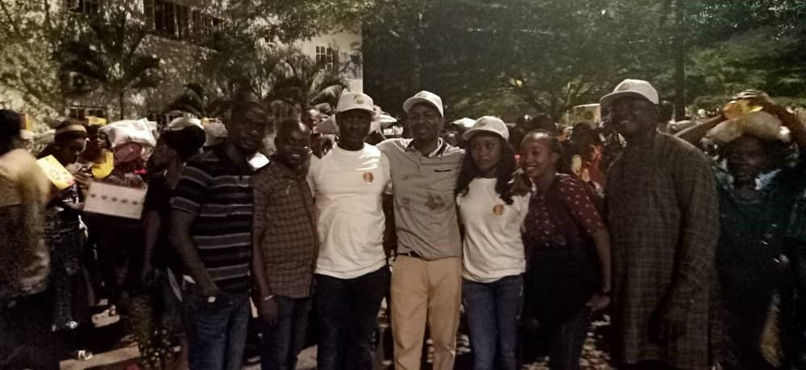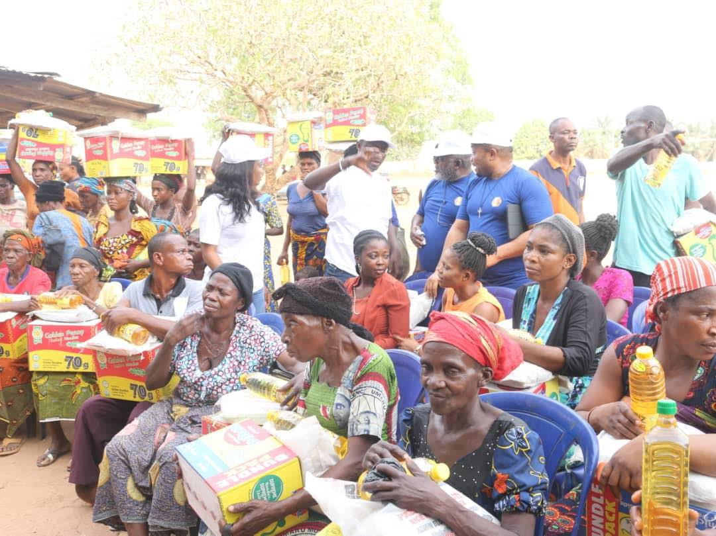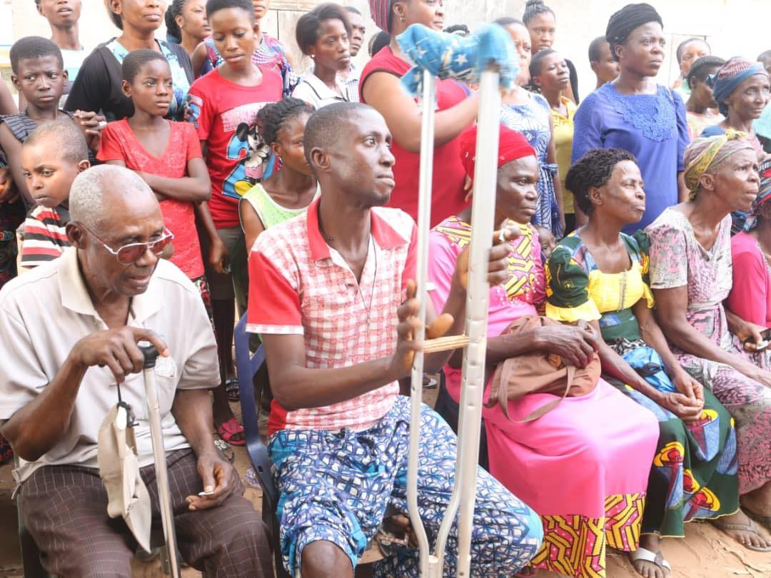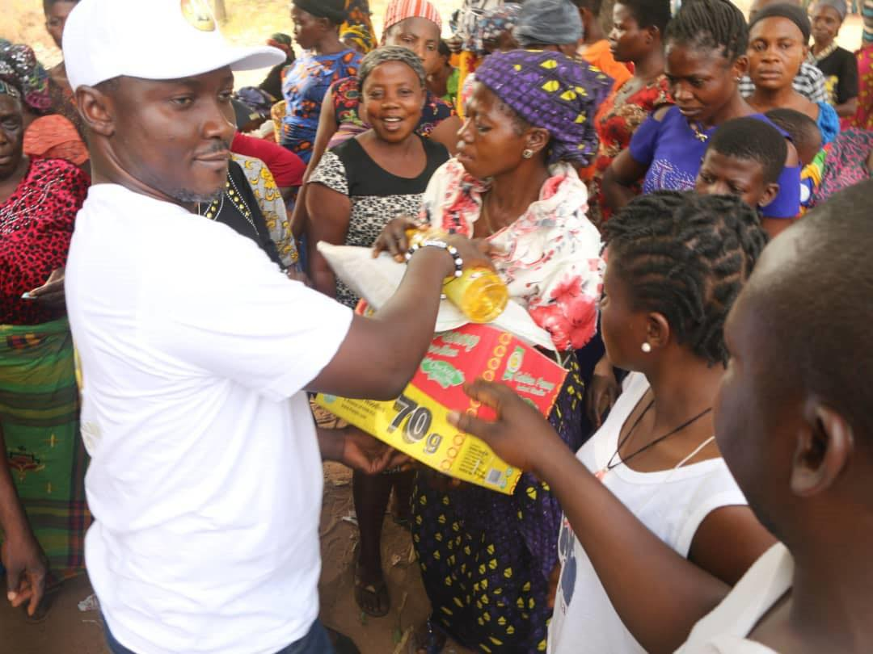

© 2022 KLUV COIN. All Rights Reserved.

[Coinpare](https://coinpare.io/)



* [DISABLE ADS](https://coinpare.io/?noAds=1)
* [Cryptocurrencies](javascript:void(0);)
* [Exchanges](https://coinpare.io/exchanges)
* [Explore](javascript:void(0);)
* [Coinpare](javascript:void(0);)
* [Donate](https://coinpare.io/donations)

Cryptocurrencies: [9,893](javascript:void(0);) Market Cap: [$1,879,871,273,104](javascript:void(0);) 24h Vol: $165,587,959,689 BTC: 39.65% ETH: 18.48% USDT: 4.43% ETH Gas: 33 gwei

Kismet Love KLUV

$20.74 (-0.95%)

ROI Calculator

KLUV

ROI x1

|  |  |
| --- | --- |
| Amount | - |
| Price | $20.74 |
| Market Cap | - |
| Diluted Market Cap | - |

KLUV

USD

**Price Change**

**1h** 0.43%

**24h** -0.95%

**7d** 2.34%

**30d** 47.75%

**1y** -

Market Cap:

-

Diluted Market Cap:

-

Volume 24h:

$79,566

Volume/Market Cap:

-

Circulating Supply:

-

Total Supply:

-

ATH (03 Mar 2022):

$19.49

From ATH / To ATH:

5.79% / -6.03%

Price BTC:

0.00052954 BTC

Price ETH:

0.00719942 ETH

Kismet Love (KLUV) is a cryptocurrency, the latest Kismet Love price is $20.74, down -0.95% in the last 24 hours. Kismet Love market cap is $0 with a 24h volume of $79,566. It has a circulating supply of 0 KLUV Kismet Love reached it's all time high on 03 March 2022 when it was trading at $19.49.



This website and the information contained herein is not intended to be a source of advice or credit analysis with respect to the material presented, and the information and/or documents contained in this website do not constitute investment advice.

**Legal**   
[Terms and Conditions](https://coinpare.io/terms-and-conditions)   
[Disclaimer](https://coinpare.io/disclaimer)   
[Privacy Policy](https://coinpare.io/privacy-policy)   
[Cookie Policy](https://coinpare.io/cookie-policy)   
[Ratings Explained](https://coinpare.io/ratings)

**Explore**   
[Global Chart](https://coinpare.io/global-charts)   
[Compare Coins](https://coinpare.io/compare)   
[Cryptocurrencies Halvings](https://coinpare.io/crypto-halvings)   
[People of Blockchain](https://coinpare.io/people)

**Coinpare**   
[Contact Us](https://coinpare.io/contact-us)   
[Donations](https://coinpare.io/donations)   
[Media](https://coinpare.io/media)

Copyright © 2022 Coinpare - All rights reserved.

Made with the right mix of [coinpaprika](https://coinpaprika.com) and [CoinGecko](https://coinpaprika.com) APIs ❤️